Come beyond the classroom to explore, experience and discover!
School Name: |  | Preferred Date/s:
School Number: |  | No. of Nights | NA
Contact Teacher: |  | Year Level:
Mobile/ After Hours: |  | No. of Students:  Numbers can be amended up until 48 hours prior to arrival.
Contact Email: |  | No. of Aboriginal Students
No. of attending Teachers/Adults:
Please note: A ratio of 1adult:15 students is recommended for supervision and assistance on outdoor activities. A minimum of 1 teacher per 30 students is required. Some activities may require higher supervision ratios.
Program Fees: | Teddy Bears Picnic: $14/Student Large group fee*: $18/Student  On-site day programs $16/Student Large group fee*: $20/Student  Off-site day programs $16/Student Large group fee*: $20/Student  Kayaking: A base rate of $200 is required for kayaking bookings. This rate includes up to 10 students. Additional students are charged at $20/student.  *Large group fees apply to schools bookings with numbers greater than 60 students. Maximum group size is 90. Large groups may be subject to availability of casual teaching staff and program requirements.
Day Program Times: | Day programs are available between 10am and 2:30pm only.
Arrival Time: |  | Departure Time:
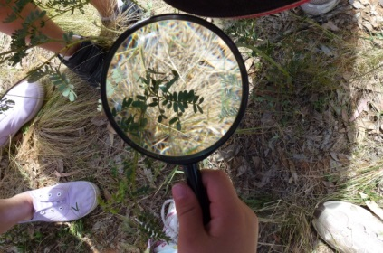
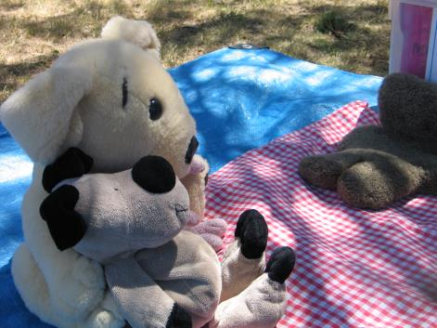
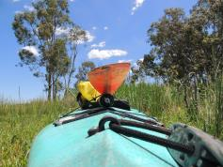
There are many ways of engaging with us to link with the new Australian curriculum.
Please outline the KLA’s or units of work that you are linking to this excursion. Use the program information overleaf to guide you, or visit our website http://wambangalang.rtweb.com.au/ to view more information about our programs. Let’s work together to create a program that your students will love and get the curriculum outcomes you are after!

Please provide us with some preliminary information!
YEAR LEVEL
 | 1 |  | 4 |  | 7 |  | 10
 | 2 |  | 5 |  | 8 |  | 11
 | 3 |  | 6 |  | 9 |  | 12
 | K – Teddy Bear’s Picnic

KEY LEARNING AREAS
You may select multiple areas if you a number of outcomes you would like to meet.
 | Geography |  | PDHPE |  | Biology |  | Mathematics
 | Science |  | English |  | Sustainability |  | ICT
 | Creative Arts |  | Earth & Environmental Science |  | Aboriginal Studies |  | History
 | STEM |  | Project Based Learning |  | Investigating Science

K-12 OUTDOOR ACTIVITIES AND TEAM BUILDING
 | Low Ropes |  | Bike Riding |  | Sensory Activities |  | Kayaking
 | Initiative Games |  | Orienteering |  | Archery |  | Wellbeing / Leadership

If Low Ropes is chosen as part of the program please inform parents or guardians on the permission notes that are sent home with students prior to visiting WEEC .
We will be in touch!
Please email this form through to wambangala-e.school@det.nsw.edu.au and our staff will be in touch to confirm your date and program.

